Statistics solutions
- a.)
 | Employed | Unemployed
With Diabetes | 717 | 146
Without Diabetes | 47057 | 5709
Total | 47774 | 5855

b.) Null hypothesis: H_{O}; P_{emd}=P_{uemd}
P_{emd} = Proportion of employed Americans with diabetes
P_{uemd} = Proportion of unemployed Americans with diabetes
Alternative hypothesis: H_{A}; P_{emd}$≠$P_{uemd}

c.)
inputs
x1 <- 717; n1 <- 47774; x2 <- 416; n2 <- 5855
# calculations
p.pool <- (x1 + x2)/(n1 + n2)
p.diff <- x1/n1 - x2/n2
se <- sqrt(p.pool*(1-p.pool)*(1/n1+1/n2))
z <- p.diff/se
p.value <- 2*pnorm(abs(z), lower.tail=F)
p.pool
[1] 0.02112663
> p.diff
[1] -0.05604222
> se
[1] 0.001991219
> z
[1] -28.14468
> p.value
[1] 2.783691e-174

The significance difference is 0.01
The p-value according to the data is 2.783691e-174
Decision:
The p-value is smaller than the significant value hence therefore we reject the null hypothesis.
Conclusion: At 1% significant level we have sufficient (statistically significant) evidence to conclude there is a difference in the proportion of employed people with diabetes and unemployed people with diabetes.
d.) p.diff + z*se*c(-1,1)
[1] -0.01406798 -0.00578760
We are 95% confident that the proportion of employed Americans with diabetes is between -0.5787% and -1.14 % lower than that of the proportion unemployed Americans.
- a.) P_{trmt}= P_{ctrl}
P_{trmt ;} represent the proportion of people who yawn under conditions of treatment.
P_{ctrl ;} represent the proportion of people who yawn under conditions of control.
# inputs
> x1 <- 10; n1 <- 34; x2 <- 4; n2 <- 16
> # calculations
> p.pool <- (x1 + x2)/(n1 + n2)
> p.diff <- x1/n1 - x2/n2
> se <- sqrt(p.pool*(1-p.pool)*(1/n1+1/n2))
> z <- p.diff/se
> p.value <- 2*pnorm(abs(z), lower.tail=F)
> # print results
> p.pool
[1] 0.28
> p.diff
[1] 0.04411765
> se
[1] 0.1361228
> z
[1] 0.3241019
> p.value
[1] 0.7458609

From the above r results we can see that the p-value is 0.7458609
Decision: At 5% significant level we do not enough evidence to reject the null hypothesis.
Conclusion: This shows that a person is likely to yawn if another person near them yawns.

b.) Pooled proportion= $\frac{x1+x2}{n1+n2}=\frac{10+4}{34+16}$ =$\frac{14}{50}≈28\%$
Under this assumptions that a person is likely to yawn if a person near them yawns we can expect to find:
For the sample of yawning under treatment (34*0.28)=9.52 $≈10$ people can yawn under treatment and 24 do not yawn.
For the sample of yawning under control (0.28*16)= 4 people can yawn under treatment and 12 do not yawn.

c.)
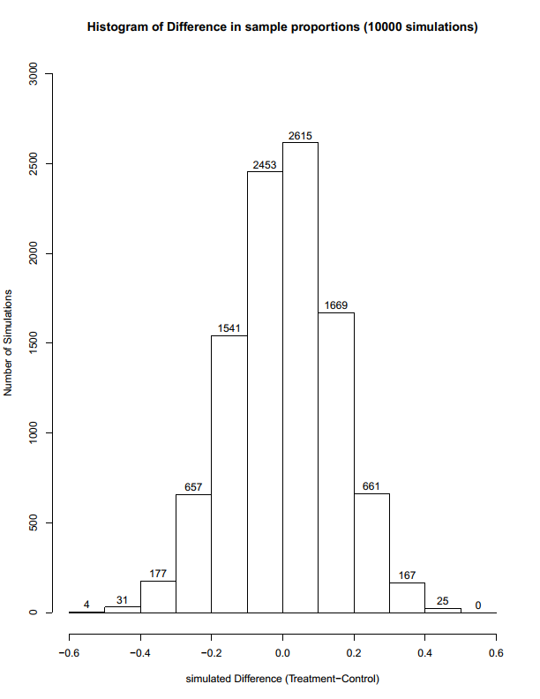
Success-failure condition
For the sample of treatment 10 yawns= ‘success’ and 34-10= 24 ‘failure’ they are at least 10
For the sample of control 4 yawns = ‘success’ and 12 ‘failure’, they are below 10
The condition of success-failure is satisfied because they are below 10.

d.) The observed difference between the two yawning rates is 0.04411765=
=4.41%
e.) When choosing our significant level to be 5%.
From the results above the p-value is 0.7458609 which is greater than the significant level.
Decision: There is no enough evidence to reject the null hypothesis.
Conclusion: A person is likely to if another person close or near him/her yawns.

